ISAD 251 Coursework – Tea Room Application

**Application Design Document**

Contents

Links 1

Introduction 1

Storyboard 1

Entity relationship diagram 5

Settings and Images **Error! Bookmark not defined.**

Feedback 6

Peer review of storyboard 6

Peer review of demo 9

Analysis 9

# Links

GitHub repository: <https://github.com/Squidgeypea/isad251_cw>

Project board: <https://github.com/Squidgeypea/isad251_cw/projects>

Video: <https://www.youtube.com/watch?v=ZK2LDWGXyJU&t=2s>

# Introduction

This application is based on the theme of a tea room situated on board a fictional steam train, The Puffing Express, in the style of a train’s restaurant car. The application could be presented within the ‘tea car’ on a self-service device, integrated into the structure of the room, like the self-service devices currently found in some popular fast food outlets, or it could be accessed using a personal mobile device.

A GitHub project board was used to organise tasks and keep track of work.

# Storyboard

The storyboard was edited to act on advice and ideas presented at the peer review.

The initial storyboard is displayed here. The final storyboard is shown on page six of this document.

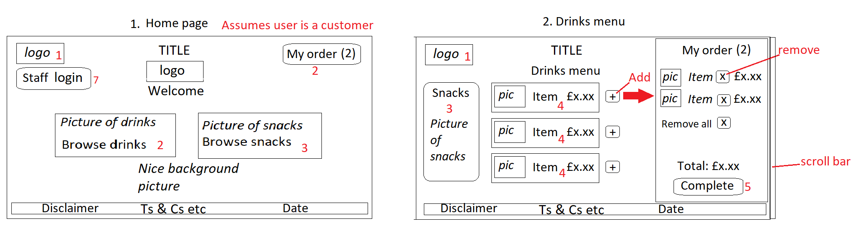

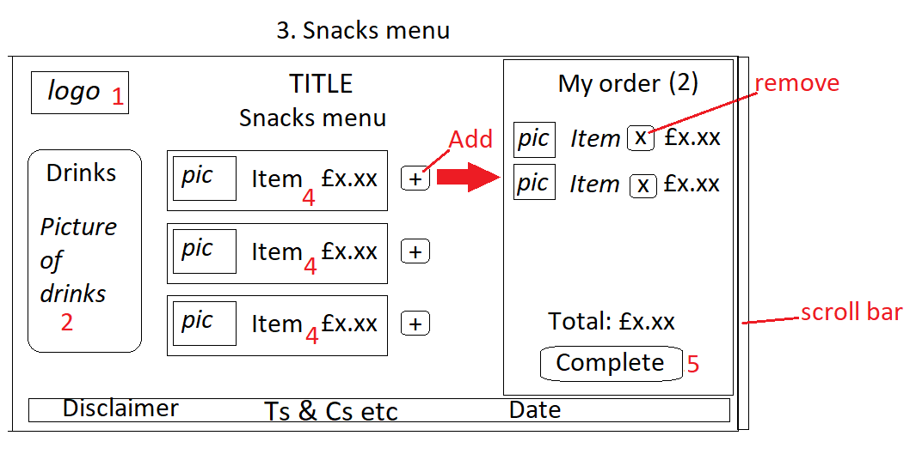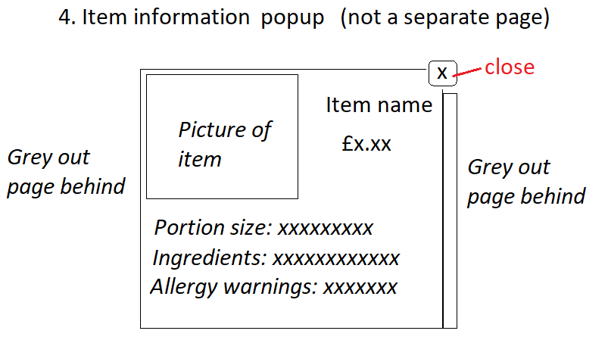

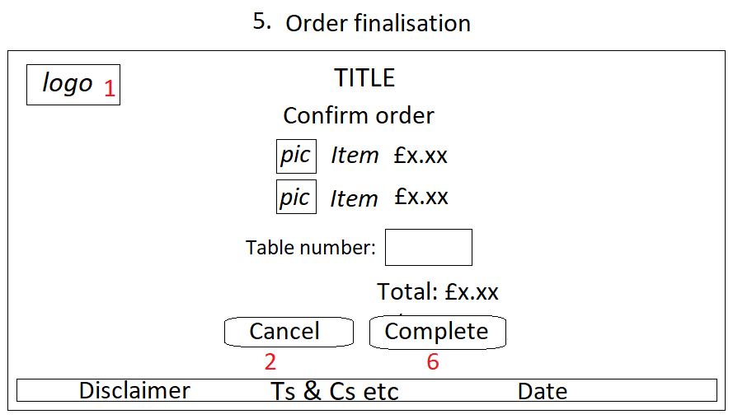 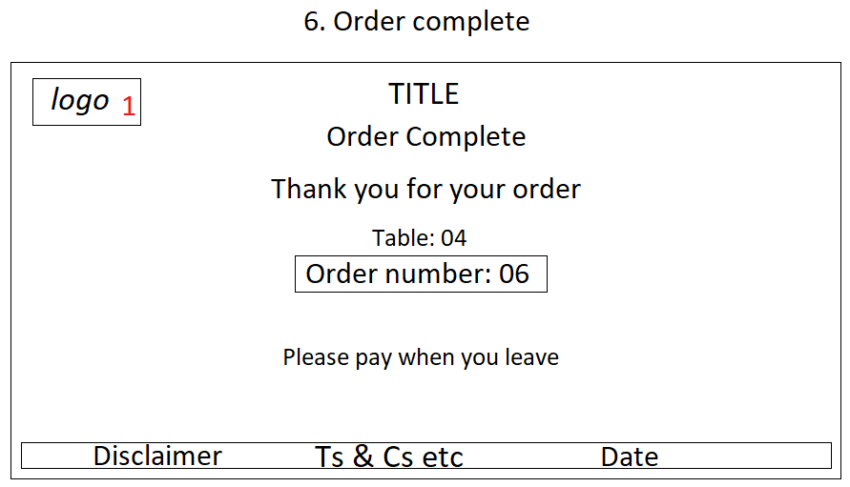

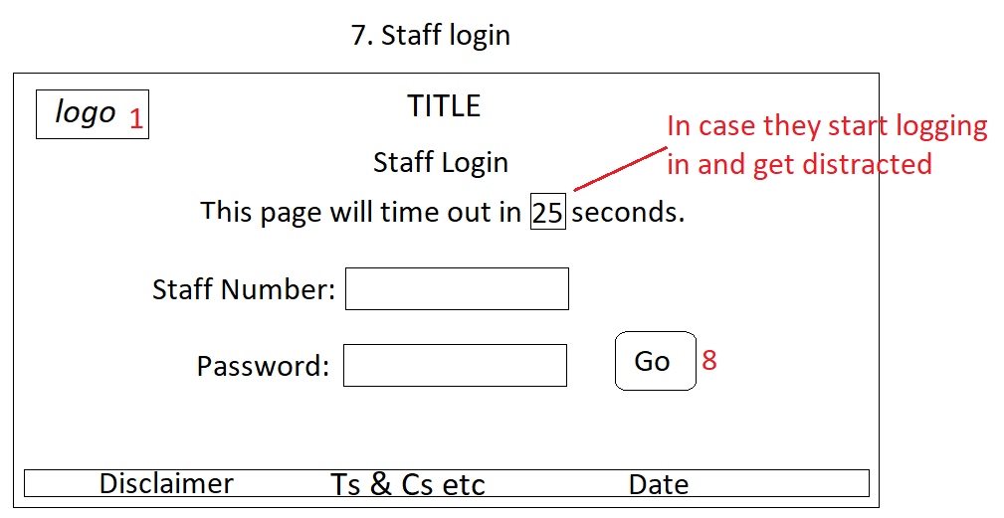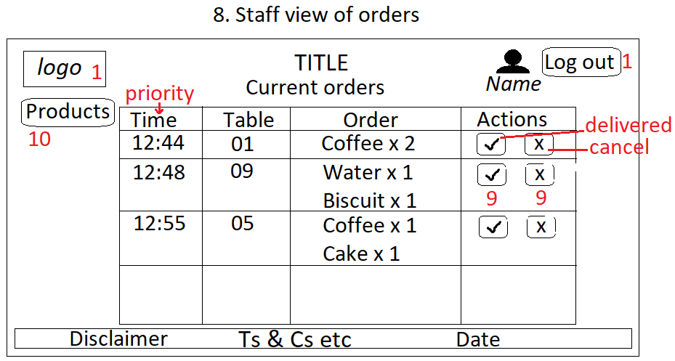

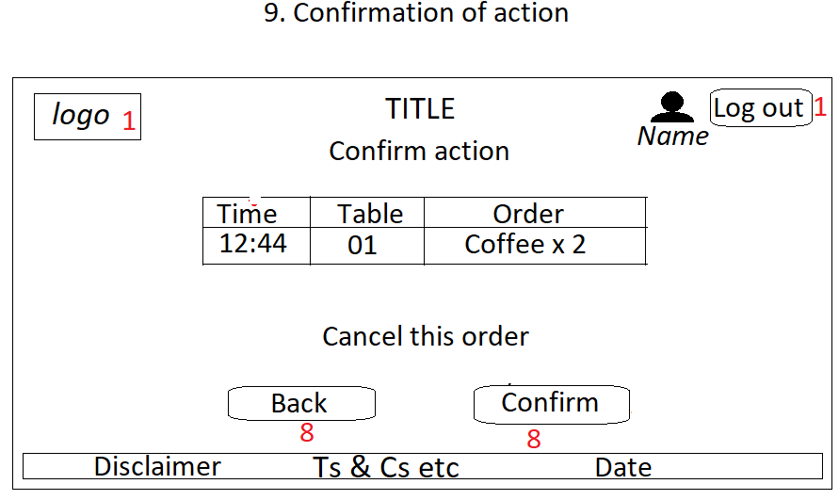 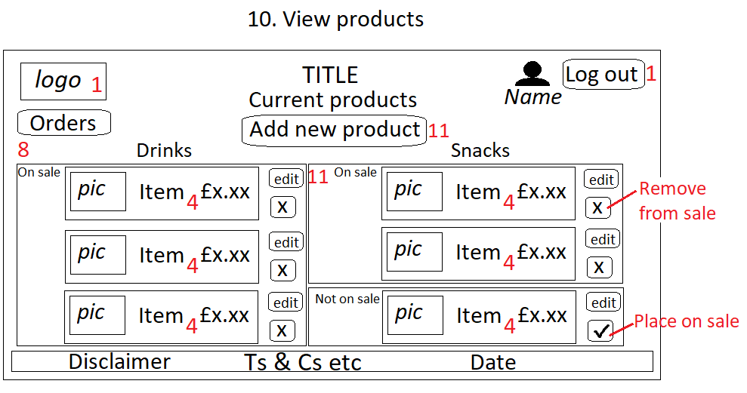

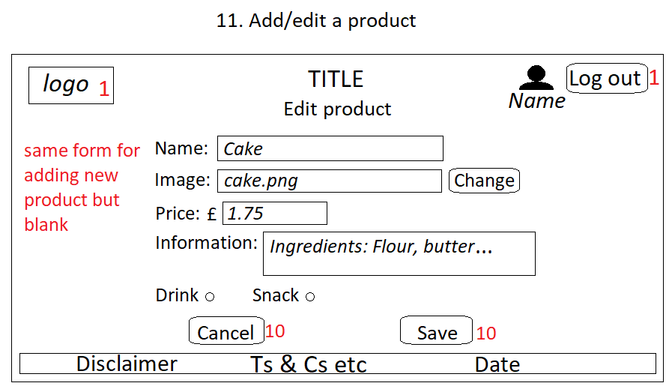

# 

# Entity relationship diagram

The entity relationship diagram was created using the web site, Draw.io.

Although the category could have been an attribute of an item, it was decided that it would be a separate entity. This was because it would then be easier for a category to be made or removed, and for categories to have their own descriptions without repeating the same thing for each item. It also led to looser coupling.

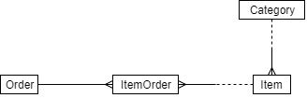

# Settings and Images

|  |  |  |  |
| --- | --- | --- | --- |
| Resource name | Resource type | Use in application | Source |
| favicon | Image | Icon | Myself |
| rooibos.jpg | Image | Customer area | https://www.thesun.co.uk/fabulous/10030257/tea-drink-teabag-plastic-billions-particles/ |
| notepad.jpg | Image | Staff area | https://ectacenter.org/decrp/type-checklists.asp |
| 1393497919.jpg | Image | Background | https://www.trainsafaris.com/uploads/2/1/2/7/21279846/1393497919.jpg |

# Feedback

## Peer review of storyboard

Peer reviews of the storyboard were carried out on 15/10/2019.

|  |  |  |  |
| --- | --- | --- | --- |
| **Reviewer name** | Avy Gurung | Max Barker | Josh Franklin |
| **Errors identified** | Add/edit item part needs a category. | Basket may be incompatible with mobile devices. | Database will not be correctly populated with new item without category. |
| **Unclear parts** | None. | None. | None. |
| **Inspiration gained** | Include date in orders. | None. | Include category in add new item part. |
| **Constructive advice** | Include category in add/edit. | Make basket a slide-out or drop-down for mobile devices. | Have ‘on sale’ Boolean rather than just deleting an item.  Include functionality for forgotten passwords and to add new staff members. |

The storyboard was changed after the peer review and it was simplified a lot because a simpler application would be better for users and better in terms of code structure.

The following changes were made to the initial storyboard, to act on feedback received during the peer review.

It was suggested that the ‘My order’ section should be simplified. This advice was followed.

It was pointed out that it was necessary to include the product category in the form to add or edit a product. This is because products will be shown to customers based on their category, which must not be null in the database.

A peer commented that it would be preferable to remove a product from sale than to remove it from view altogether. This way, a staff member could easily decide to sell the product again in future without having to recreate the product. Since it would be easy to put the removed product back on sale, it was decided that screen 12 would no longer be necessary, and it was removed from the storyboard. Screen 10 was adapted to show the change.

Below is the simplified final design for the storyboard:

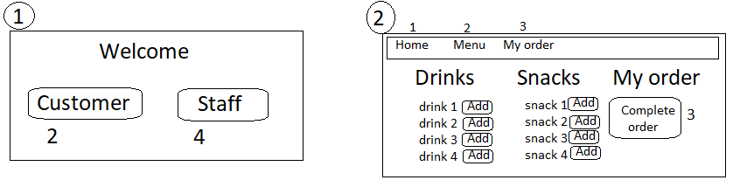

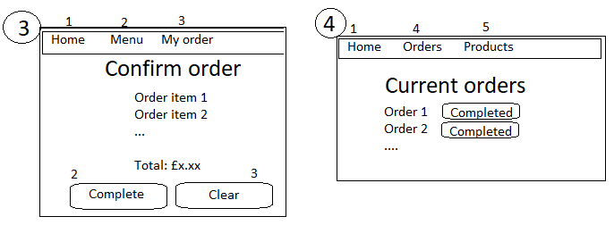

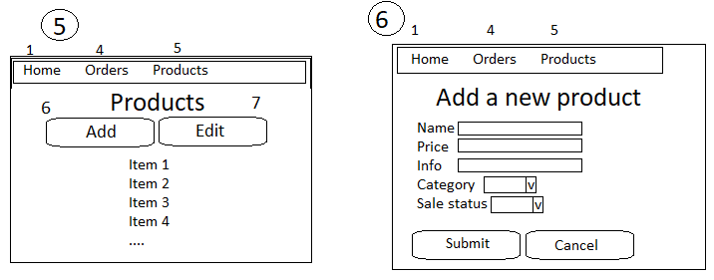

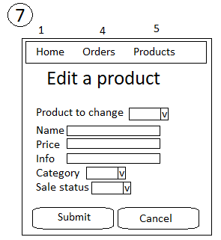

## Peer review of demo

|  |  |  |  |
| --- | --- | --- | --- |
| **Reviewer name** | Morgan Wilson | Morgan Hill | Dan Skillman |
| **Errors identified** | Staff member can’t remove an order from their view of orders. | When a new customer uses the system, the previous customer’s order is still shown. | Customer might not realise that their items have been added. |
| **Unclear parts** | None. | None. | None. |
| **Inspiration gained** | Use nice looking buttons rather than just text. | None. | Structure the README file so that it’s easy to read. |
| **Constructive advice** | Make sure staff can update/remove orders from their list. | Make sure the page is reset each time a new customer uses it. | Display a message telling them that their items were added. |

It was suggested that the staff should be able to remove an order from their view once it was completed. This advice was following by adding a ‘completed’ field to the database. This way, orders could be shown to staff if they had not been completed, and if they had been completed, they would remain in the database but not be visible.

It was pointed out that a customer should start on a ‘blank canvas’, a page with nothing already selected. This was achieved by clearing the incomplete orders each time the home page is loaded. This ensures that the basket cannot fill up with unwanted orders.

A peer commented that customers should be alerted when they added items to their basket. This was done by including a code block in the view which displayed a message on the screen when they added an item to their order.

# Analysis

Listed below are further improvements which could have been made, in addition to the suggestions from the reviews.

* Include the option to add a new category besides drinks and snacks.
* Make the application compatible for mobile devices.
* Include a login system for different users.
* Provide the option to add a new staff member.

# Screenshots

